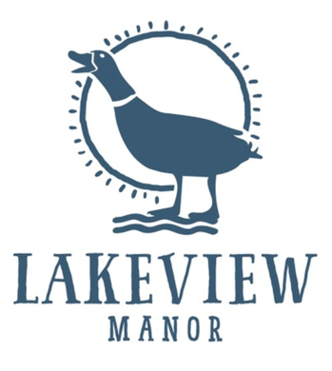

We kindly ask that you help yourselves to items from the buffet.
Please order any of the following items from the waiting staff.

Breakfast Menu

Warm Porridge, Brown Sugar

***

Grilled Back Bacon, Sausage, Hash Brown, Grilled Fresh Tomato, Baked Beans,
Fresh Button Mushrooms & Black Pudding
Vegetarian/Vegan Sausage, Hash Brown, Grilled Fresh Tomato, Baked Beans,
Fresh Button Mushrooms
Choice of Egg - Fried, Scrambled or Poached

Smoked Salmon, Scrambled Egg and Toasted Muffin

Eggs Benedict: Poached Eggs, Hollandaise Sauce, Gammon Ham
Eggs Royale: Poached Eggs, Hollandaise Sauce, Smoked Salmon
Eggs Florentine: Poached Eggs, Hollandaise Sauce, Wilted Spinach
(served on a toasted muffin)

***

Wholemeal or White Toast

***

Hotel Residents – breakfast included

Non-residents
Adults £15/Children £7.50

